

**Leaf Disease Detection using Deep Learning**

**A MINOR PROJECT REPORT**

***Submitted by***

**KARNA RUTHWIK REDDY (RA2011026010232) GUNTI MEGHANATH (RA201102010219)**

*Under the guidance of*

**DR. S JOSEPH JAMES**

ASSISTANT PROFESSOR, DEPARTMENT OF CINTEL

***in partial fulfillment for the award of the degree of***

**BACHELOR OF TECHNOLOGY**

in

**COMPUTER SCIENCE & ENGINEERING**

of

**FACULTY OF ENGINEERING AND TECHNOLOGY**



S.R.M.Nagar, Kattankulathur, Chengalpattu District

**NOVEMBER 2023**

.

SRM INSTITUTE OF SCIENCE AND TECHNOLOGY

(Under Section3 of UGC Act,1956)

**BONAFIDE CERTIFICATE**

Certified that 18CSP107L minor project report titled “**Leaf Disease Detection using Deep Learning**” is the bonafide work of “**Karna Ruthwik Reddy(RA2011026010232), G.Meghanath(RA201102010219)”**

who carried out the minor project work under my supervision. Certified further, that to the best of my knowledge the work reported herein does not form any other project report or dissertation on the basis of which a degree or award was conferred on an earlier occasion on this or any other candidate.

# SIGNATURE

Dr. S JOSEPH JAMES

Associate professor

# SIGNATURE

Dr. Annie Uthra R

# HEAD OF THE DEPARTMENT

Associate professor

Dept.of Computational intellegence

Signature ofthe Panel Head Panel Head Name

Panel Head Affiliation

Department of Computing Technologies

**SRM Institute of Science and Technology**

**Own Work Declaration Form Degree/Course :** B.Tech in Computer Science and Engineering in specialization with AI&ML.

S**tudent Names :** KARNA RUTHWIK REDDY, GUNTI MEGHANATH.

**Registration Number :** RA2011026010232, RA201102010219.

# Title of Work :Leaf disease detection using Deep leaning.

I/We here by certify that this assessment compiles with the University’s Rules and Regulations relating to Academic misconduct and plagiarism, as listed in the University Website, Regulations, and the Education Committee guidelines.

I/We confirm that all the work contained in this assessment is our own except where indicated, and that we have met the following conditions:

* Clearly references/listed all sources as appropriate
* Referenced and put in inverted commas all quoted text (from books, web, etc.)
* Given the sources of all pictures, data etc that are not my own.
* Not made any use of the report(s) or essay(s) of any other student(s)either past or present
* Acknowledged in appropriate places any help that I have received from others (e.g fellow students, technicians, statisticians, external sources)
* Compiled with any other plagiarism criteria specified in the Course hand book/University website

I understand that any false claim for this work will be penalized in accordance with the University policies and regulations.

|  |
| --- |
| **DECLARATION:** |
| I am aware of and understand the University’s policy on Academic misconduct and plagiarism and I certify that this assessment is my/our own work, except where indicated by referring, and that I have followed the good academic practices noted above.  **Student1Signature: Student2Signature: Date:** |
| If you are working in a group, please write your registration numbers and sign with the date for every student in your group. |

# ACKNOWLEDGEMENT

We express our humble gratitude to **Dr C. Muthamizhchelvan**, Vice-Chancellor, SRM Institute of Science and Technology, for the facilities extended for the project work and his continued support.

We extend our sincere thanks to Dean-CET, SRM Instituteof Science and Technology, Dr

**T.V.Gopal**, for his invaluable support.

We wish to thank **Dr Revathi Venkataraman,** Professor & Chairperson, School of Computing,SRM Institute of Science and Technology, for her support throughout the project work.

We are incredibly grateful to our Head of the Department, Professor, Department of Data Science and Business Systems, SRM Institute of Science and Technology, for her suggestions and encouragement at all the stages of the project work.

We want to convey our thanks to our program coordinators , Professor, Department of Data Science and Business Systems, SRM Institute of Science and Technology, for her inputs during the project reviews and support.

We register our immeasurable thanks to our Faculty Advisor, Associate Professor, Department of Data Science and Business Systems, SRM Institute of Science and Technology, for leading and helping us to complete our course.

Our inexpressible respect and thanks to my guide, Assistant Professor, Department of Data Science and Business Systems, SRM Institute of Science and Technology, for providing me with an opportunity to pursue my project under his/her/their mentor-ship. He/She/They provided me with the freedom and support to explore the research topics of my interest. Her/His/Their passion for solving problems and making a difference in the world has always been inspiring.

We sincerely thank the Data Science and Business Systems staff and students, SRM Institute of Science and Technology, for their help during our project. Finally, we would like to thank parents, family members, and friends for their unconditional love, constant support, and encouragement.

**ABSTRACT**

The economy plays a pivotal role in agricultural productivity. Plant diseases are a common concern in agriculture, but their detection has become more viable due to economic advancements. Presently, the scrutiny of plant disease detection is expanding, especially in the surveillance of vast and diverse crop fields. Farmers often encounter challenges when switching from one disease management strategy to another. The standard approach for disease detection involves identifying or spotting tomato leaf diseases, which requires the expertise of surveillance and monitoring professionals. Failing to take proper control measures can significantly impact plant health, affecting both crop quality and quantity.

Efficient and constructive methods for disease detection involve mechanized techniques and methodologies. These methods alleviate the substantial labor involved in monitoring extensive agricultural operations. Early disease symptoms can

be detected in the initial stages, appearing on plant leaves. Research in this area explores algorithms for image segmentation and automated classification, facilitating the detection of leaf diseases in plants. Various disease classification methods are also covered, offering diverse approaches to detect and manage plant diseases.

The integration of deep learning techniques into plant disease recognition offers several advantages, mitigating the drawbacks associated with the manual selection of disease spot features. It enhances the objectivity of plant disease feature extraction, thereby boosting research efficiency and expediting technological advancements. This review comprehensively outlines recent developments in deep learning technology as applied to the identification of crop leaf diseases. The paper also delves into the present trends and challenges in the realm of plant leaf disease detection, incorporating advanced imaging methodologies. We aspire for this work to serve as a valuable reference for researchers engaged in the study of plant disease and insect pest detection. Additionally, we engage in discussions regarding the current challenges and issues that necessitate resolution in this field.

**Keyword:** Plant leaf disease images, deep learning, Machine Learning, Dense Net, ANN, CNN, Resnet50.

# LEAF DISEASE DETECTION USING DEEP LEARNING

|  |
| --- |
| **CONTENT** |
| **Abstract** |
| **1.INTRODUCTION** |
| 1.1 Motivation |
| 1.2 Problem Statement |
| 1.3 Objective of the Project |
| 1.4 Scope |
| 1.5 Project Introduction |
| **2.LITERATURE SURVEY** |
| 2.1 Related Work |
| **3. SYSTEM ANALYSIS** |
| 3.1 Existing System |
| 3.2 Disadvantages |
| 3.3 Proposed System |
| 3.4 Advantages |
| 3.5 work Flow of Proposed system |

|  |
| --- |
| **4. REQUIREMENT ANALYSIS** |
| 4.1 Function and non-functional requirements |
| 4.2 Hardware Requirements |
| 4.3 Software Requirements |
| 4.4 Architecture |
| **5. METHODOLOGY** |
| 5.1 CNN |
| 5.2 ANN |
| 5.3 RES NET50 |
| 5.4 DENSE NET-201 |
| **6. SYSTEM DESIGN** |
| 6.1 Introduction of Input design |
| 6.2 UML Diagram (class, use case, sequence, collaborative, deployment, activity, ER diagram and Component diagram) |
| 6.3 Data Flow Diagram |
| **7. IMPLEMENTATION AND RESULTS** |
| 7.1 Modules |
| 7.2 Output Screens |
| **7. SYSTEM STUDY AND TESTING** |
| 8.1 Feasibility study |

|  |
| --- |
| 8.2 Types of test & Test Cases |
| **9. CONCLUSION** |
| **10. FUTURE ENHANCEMENT** |
| **11. REFERENCES** |

# INTRODUCTION

* 1. **Motivation:**

The adoption of deep learning for leaf disease detection in the agricultural sector is driven by its transformative potential. Through the utilization of sophisticated algorithms and extensive datasets, deep learning models have the capacity to provide precise and rapid identification of diseases affecting plant leaves. This technology offers the promise of early and accurate disease detection, facilitating timely interventions that can effectively mitigate crop losses, optimize resource allocation, and bolster food security. Furthermore, the automation of disease detection processes reduces the need for extensive manual labor and enhances

scalability. As a result, deep learning becomes a pivotal tool in modern agriculture, contributing to increased yields, the promotion of sustainable farming practices, and ultimately playing a role in global food production and the well-being of farmers and communities.

# Problem Statement:

The challenge in leaf disease detection using deep learning lies in the development of a precise and efficient system that can identify plant diseases accurately based on images of leaves. This solution is designed to elevate agricultural productivity by enabling the early detection and diagnosis of diseases, facilitating timely interventions to prevent crop losses. Leveraging deep learning algorithms, the system's objectives include distinguishing between healthy and diseased leaves, classifying various diseases, and furnishing farmers with actionable insights for effective disease management and the maintenance of crop health. Ultimately, the overarching aim is to optimize agricultural practices and make significant contributions to global food security through the early and precise detection of plant diseases.

# Objective of the Project:

The primary goal of the "Leaf Disease Detection Using Deep Learning" project is to establish a highly accurate and efficient automated system for the early detection of diseases in plant leaves. Leveraging state-of-the-art deep learning techniques, the project's core objective is to develop a model capable of analyzing leaf images and accurately classifying them based on the presence of diseases. This system is envisioned as a valuable tool for farmers and agricultural professionals, facilitating timely disease identification, which, in turn, enables targeted treatments and minimizes potential crop damage. Ultimately, the overarching mission of the project is to significantly enhance crop yields and advocate for sustainable agricultural practices by advancing the cause of early and precise disease detection in the field.

# Scope:

Leaf disease detection using deep learning revolves around the process of training models to meticulously analyze leaf images and promptly identify diseases or

irregularities. In this domain, deep learning algorithms, particularly Convolutional Neural Networks (CNNs), play a pivotal role. These algorithms are adept at learning intricate patterns and features from a comprehensive dataset that encompasses both healthy and diseased leaves. Their ability to automate the detection process ensures a high level of accuracy. The applications of such technology extend to precision agriculture, where it allows for timely interventions to prevent crop damage and ultimately augments agricultural productivity. Consequently, it plays a significant role in fostering food security and promoting sustainable farming practices. The continuous progress in research and the evolution of deep learning techniques further refine and expand the capabilities of leaf disease detection systems, promising even greater levels of accuracy and efficiency.

# Project Introduction:

Welcome to our groundbreaking initiative, "Leaf Disease Detection Using Deep Learning," a project with the vision to transform agricultural practices and secure sustainable crop yields. Agriculture is the cornerstone of our society, and its optimization is paramount for global food security. However, the presence of plant diseases presents a significant challenge to crop health and yield. Our project aims to confront this challenge by harnessing state-of-the-art deep learning techniques to craft a precise and efficient system for the automated detection of leaf diseases.

Deep learning, a subset of artificial intelligence, has exhibited immense promise across various domains, including image recognition. With this potential in mind, we are committed to constructing a robust model with the capability to scrutinize images of plant leaves and accurately pinpoint disease symptoms. Through this endeavor, our objective is to empower farmers with the ability to identify diseases in their early stages, take swift and informed actions, and effectively curtail crop damage.

Our project unfolds with several key objectives, encompassing the collection of a diverse dataset of plant leaf images representing varying health and disease stages, meticulous data preprocessing to ensure quality and relevance, the creation and training of deep learning models featuring convolutional neural networks (CNNs),

and rigorous performance evaluations. We aim for high accuracy, sensitivity, and specificity to guarantee dependable disease detection.

The impact of our project reverberates widely, offering direct benefits to farmers, agricultural industries, and ultimately, the global population. By facilitating early disease detection and timely intervention, our aim is to minimize crop losses, enhance productivity, reduce the reliance on harmful pesticides, and champion sustainable and eco-friendly farming practices.

We invite you to join us on this journey to revolutionize agriculture through the transformative potential of deep learning, charting a path toward a more sustainable and food-secure future.

# 2.1 LITERATURE REVIEW

**2.1 Related Work:**

1. **Maniyath, S. R., P V, V., M, N., R, P., N, P. B., N, S., & Hebbar, R:** Crop diseases pose a significant threat to food security, particularly in regions lacking the necessary infrastructure for their rapid detection. The emergence of accurate techniques in leaf-based image classification has shown promising results. This paper employs the Random Forest algorithm to differentiate between healthy and diseased leaves using datasets created for this purpose. The proposed paper encompasses several implementation phases, including dataset creation, feature extraction, classifier training, and classification. The datasets, comprising both

diseased and healthy leaves, are collectively trained using Random Forest to classify the images accordingly. Feature extraction is performed using the Histogram of Oriented Gradients (HOG) method.

In summary, harnessing machine learning to train on publicly available large datasets offers a practical means of detecting plant diseases on a significant scale. Farmers in rural areas often find it challenging to identify diseases in their crops, and it may not be feasible for them to access agricultural offices for diagnosis. Our primary objective is to detect diseases in plants by observing their morphology through image processing and machine learning. To improve detection rates and accuracy, we have employed advanced approaches such as machine learning and deep learning algorithms. This paper contributes to the growing body of research in the field of machine learning for plant disease detection and diagnosis, aiming to enhance agricultural practices and address the challenges posed by crop diseases.

**Summary**: In the initial phase, the image processing workflow commences by converting the RGB image into a grayscale image. This transformation is a prerequisite because certain shape descriptors like Hu moments and Haralick features are designed to be computed over a single channel. Hence, converting the RGB image to grayscale is essential before the subsequent computation of these features. Furthermore, the calculation of a histogram necessitates a preliminary conversion of the image to HSV (hue, saturation, and value) format. This HSV conversion is performed to facilitate the histogram analysis. The primary objective of our project revolves around the detection of whether a leaf is diseased or healthy. This task is accomplished with the assistance of a Random Forest classifier, as illustrated in the methodology. The algorithm's purpose is to identify abnormalities in plants, whether they are in a greenhouse environment or a natural setting. It is worth noting that the images are typically captured with a plain background to eliminate occlusion and enhance the accuracy of disease detection. To assess the algorithm's performance, it has been compared with other machine learning models, with a focus on achieving optimal accuracy in the classification of healthy and diseased leaves.

1. **Hassan, S. M., Maji, A. K., Jasiński, M., Leonowicz, Z., & Jasińska, E.:** Detecting and preventing crop diseases in a timely manner is of utmost importance for enhancing agricultural production. This paper presents an innovative approach where deep convolutional neural network (CNN) models are employed for the identification and diagnosis of plant diseases based on their leaf images. CNNs have garnered considerable success in the domain of machine vision, but standard CNN models often involve a high number of parameters and significant computational costs. In this study, the authors have opted for depth-separable convolution, replacing the standard convolution, to reduce the number of parameters and computational overhead.

The models developed in this research were trained using an open dataset that encompasses 14 distinct plant species and 38 categorical disease classes, along with healthy plant leaves. To assess the model's performance, various parameters, including batch size, dropout rates, and different numbers of epochs, were taken into account. The outcome of this endeavor demonstrates impressive disease classification accuracy rates: 98.42% for InceptionV3, 99.11% for InceptionResNetV2, 97.02% for MobileNetV2, and 99.56% for EfficientNetB0. These results surpass the performance of traditional handcrafted-feature-based approaches.

Furthermore, when compared to other deep learning models, the implemented model not only exhibited superior accuracy but also required less training time. The suitability of the MobileNetV2 architecture for mobile devices, given its optimized parameters, is an additional advantage. The high accuracy achieved in disease identification underscores the potential of deep CNN models in efficiently identifying plant diseases, with implications for real-time disease detection in agricultural systems. This research showcases the promise of deep learning in the agricultural sector, offering an efficient and accurate approach to disease identification and management.

**Summary:** Numerous methods have been developed for the detection and classification of plant diseases using images of diseased leaves. However, despite

these advancements, there is still a lack of efficient and commercially viable solutions for disease identification in the field. In this study, we have leveraged four distinct deep learning (DL) models, namely InceptionV3, InceptionResnetV2, MobileNetV2, and EfficientNetB0, for the purpose of detecting plant diseases using images of both healthy and diseased plant leaves.

The model training and testing were conducted using the PlantVillage dataset, a standard resource containing 53,407 images captured under controlled laboratory conditions. This dataset encompasses 38 different classes of images representing various healthy and diseased leaves from 14 different plant species. The data were split into an 80-20 ratio, with 80% allocated for training and 20% for testing. Notably, the EfficientNetB0 model exhibited the highest accuracy rate, achieving an impressive 99.56% accuracy.

On average, the training time for the MobileNetV2 and EfficientNetB0 architectures was comparatively shorter than other deep learning models, with training durations of 565 and 545 seconds per epoch, respectively, for color images. In comparison to alternative deep learning approaches, our implemented model demonstrated superior predictive capability, exhibiting enhanced accuracy and loss performance. Additionally, the MobileNetV2 architecture is optimized for efficiency, minimizing parameters and operations, making it well-suited for deployment on mobile devices. This research underscores the potential of deep learning models in addressing the pressing issue of plant disease detection, offering enhanced accuracy, efficiency, and practicality for real-world agricultural applications.

1. **Muhammad E.H. Chowdhury, Tawsifur Rahman, Amith Khandakar, Nabil Ibtehaz,:** Plants play a pivotal role as a primary food source for the global population, and the impact of plant diseases on production loss is a significant concern. Addressing this challenge necessitates continuous monitoring, but manual plant disease monitoring is both labor-intensive and susceptible to errors. Early disease detection in plants through the application of computer vision and artificial

intelligence (AI) offers a promising solution, mitigating the adverse effects of diseases and alleviating the limitations of human monitoring.

In this comprehensive study, we have extensively evaluated the performance of various state-of-the-art convolutional neural network (CNN) classification architectures, including ResNet18, MobileNet, DenseNet201, and InceptionV3. The assessment utilized a dataset comprising 18,162 plain tomato leaf images for the classification of tomato diseases. The study encompasses a comparison of model performance for binary classification (distinguishing healthy and unhealthy leaves), six-class classification (categorizing healthy and various groups of diseased leaves), and ten-class classification (classifying healthy and different types of unhealthy leaves).

The results revealed that InceptionV3 achieved exceptional performance in binary classification, with an accuracy of 99.2%. DenseNet201 also excelled in the six-class classification, achieving an accuracy of 97.99%, while it further demonstrated an accuracy of 98.05% in the ten-class classification. These findings underscore the superiority of deep architectures in disease classification across the three experimental studies. The performance outcomes reported in this study surpass those in existing literature, emphasizing the efficacy of the models in enhancing disease classification in the context of plant

**Summary:** The journey through the various stages of applying machine learning to agriculture is an exploration of infinite possibilities, accompanied by illustrative case studies. Notably, within this landscape, the utilization of state-of-the-art pre-trained convolutional neural network (CNN) models, such as ResNet, MobileNet, DenseNet201, and InceptionV3, has demonstrated remarkable efficacy in disease classification based on plant leaf images. Among these architectures, DenseNet201 particularly excels in its ability to extract discriminative features from images.

The trained models generated through this research hold the potential to revolutionize disease detection in plants, particularly offering early and automated

identification. This timely detection enables swift adoption of preventive measures. This study's implications extend beyond theoretical research, as it paves the way for practical applications in the agricultural sector. By integrating cutting-edge technology, including smartphones, drone cameras, and robotic platforms, the research aims to facilitate early and automated disease detection in tomato crops.

Furthermore, the proposed framework can be integrated with a feedback system that provides invaluable insights, treatment recommendations, disease prevention strategies, and effective control techniques. This holistic approach is envisioned to result in improved crop yields, fostering the goal of enhanced agricultural productivity and food security.

1. **Zhang, Y., Song, C., & Zhang., D.** In the pursuit of enhancing the accuracy of recognition models for crop disease leaves and the precise localization of diseased leaves, this paper introduces an improved Faster R-CNN (Region-based Convolutional Neural Network) approach for the detection of healthy tomato leaves and four specific diseases: powdery mildew, blight, leaf mold fungus, and ToMV. The proposed method incorporates several key innovations to refine the disease detection process.

First, the traditional VGG16 model, used for image feature extraction, is replaced with a deeper depth residual network, enabling the extraction of more intricate disease-related features. This deeper feature extraction process contributes to more accurate disease identification.

Second, the paper employs the k-means clustering algorithm to cluster the bounding boxes, which is a crucial aspect of object detection. The clustering results are utilized to enhance the anchor boxes, making them align more closely with the actual bounding boxes in the dataset.

Finally, the paper conducts a k-means experiment using three different feature extraction networks to evaluate the performance of the improved method. The experimental findings reveal that the enhanced approach for crop leaf disease detection achieves a 2.71% increase in recognition accuracy and a faster detection speed compared to the original Faster R-CNN.

Crop disease detection is fundamental to ensuring crop quality and preventing disease-related losses. Traditional detection methods often rely on manual observation, resulting in low detection efficiency and reliability. This is exacerbated by the fact that many farmers lack professional knowledge, and agricultural experts cannot be present in the fields at all times, leading to missed opportunities for disease prevention. The improved Faster R-CNN approach offers a promising solution to address these challenges, providing more reliable and efficient crop disease detection to support better crop management practices.

**Summary:** The paper introduces the Faster R-CNN algorithm as a means to detect diseased tomato leaves, offering a dual capability to recognize tomato diseases and pinpoint the locations of affected tomato leaves. To refine the performance of the algorithm and ensure that the anchors closely align with the ground truth of the dataset, the k-means clustering algorithm is applied to cluster the bounding boxes of tomato disease images. The anchor boxes are subsequently improved based on the clustering results. In the process of feature extraction, ResNet101 is selected as a replacement for VGG16, enabling the extraction of deeper and more meaningful features associated with tomato diseases.

The experimental results corroborate the effectiveness of this method in detecting and recognizing tomato diseases, demonstrating superior detection accuracy compared to the original Faster R-CNN. It's important to note that the dataset used in this study consists of laboratory data, allowing for the detection of a single leaf disease in each image. Future research endeavors will encompass the collection of images from natural plant environments, enabling more comprehensive detection.

Moreover, tomato diseases exhibit distinct characteristics in different parts of the plant, including the fruits and stems. Some diseases manifest as a combination of these characteristics. Future research initiatives should take these multifaceted factors into account to conduct comprehensive diagnoses, ultimately contributing to the advancement of smart agriculture practices and the holistic management of tomato diseases.

1. [**Aakanksha Rastogi**](https://ieeexplore.ieee.org/author/37085484349)**;** [**Ritika Arora**](https://ieeexplore.ieee.org/author/37085486433)**;** [**Shanu Sharma**](https://ieeexplore.ieee.org/author/37085495564)**:** In the realm of agriculture, the issue of leaf diseases has become a significant problem, leading to a considerable reduction in both the quality and quantity of agricultural crop yields. Consequently, the automated identification of diseases on leaves is of paramount importance in the agricultural sector. This research paper presents a straightforward and computationally efficient method for the identification and grading of leaf diseases using digital image processing and machine vision technology.

The proposed system consists of two distinct phases. In the first phase, the plant is identified based on the characteristics of its leaves. This process encompasses preprocessing of leaf images, extracting relevant features, and employing Artificial Neural Network (ANN) for training and classification to recognize the type of plant based on its leaves.

In the second phase, the disease affecting the leaf is identified and classified. This involves utilizing K-Means-based segmentation to isolate the affected area, extracting features from the diseased portion, and employing an ANN for classifying the specific disease. Subsequently, the disease is graded based on the extent of its presence on the leaf.

**Summary:** The paper discusses a method for automated identification and grading of leaf diseases in agriculture using digital image processing and machine vision. The system is divided into two phases. In the first phase, the plant is recognized based on leaf features using preprocessing and an Artificial Neural Network (ANN). In the second phase, diseases on the leaf are classified through K-Means-based segmentation and ANN-based disease identification. Disease grading is also performed based on the severity of the disease on the leaf.

1. [**Nithish Kannan E.**](https://ieeexplore.ieee.org/author/37088440327)**;** [**Kaushik M.**](https://ieeexplore.ieee.org/author/37086612059)**;** [**Prakash P.**](https://ieeexplore.ieee.org/author/37088440390)**;** [**Ajay R.**](https://ieeexplore.ieee.org/author/37088440081)**;** [**Veni S.**](https://ieeexplore.ieee.org/author/37089378438)**:** This project focuses on the detection of diseases in tomato leaves utilizing Convolutional Neural

Networks (CNNs), a subset of deep neural networks. Initially, the dataset is organized to isolate tomato leaves. Transfer learning is employed by importing a pre- trained model, ResNet-50, which is then fine-tuned for our specific classification task. To improve the model's quality and bring it closer to real-world disease detection, data augmentation techniques are applied. With these steps in mind, a tomato leaf disease detection model is created using PyTorch, leveraging deep CNNs.

Subsequently, a testing dataset is used to validate the model's performance based on the knowledge transferred from the ResNet-50 model. The classification task focuses on six of the most common tomato crop diseases. Data augmentation is used to expand the dataset to four times its original size, and the model achieves an impressive accuracy rate of 97%.

**Summary:** This project aims to detect diseases in tomato leaves using Convolutional Neural Networks (CNNs). It begins by preprocessing the dataset to isolate tomato leaves. Transfer learning is employed by fine-tuning a pre-trained model, ResNet-50, to address the classification problem. Data augmentation techniques are used to enhance the model's performance. The resulting tomato leaf disease detection model, implemented in PyTorch with deep CNNs, is evaluated on a testing dataset. The model achieves a high accuracy rate of 97% and can identify six prevalent tomato crop diseases.

1. **Nitesh Agrawal; Jyoti Singhai; Dheeraj K. Agarwal:** In today's technology- driven era, many fields are seeking efficient and cost-effective software solutions to replace manual decision-making processes. Support Vector Machine (SVM) was originally designed for binary classification but can be adapted for multi-class problems with some modifications. This project aims to enhance the classification of leaf diseases.

Traditionally, most efforts have focused on extracting statistical features from RGB signals converted into LAB color space. However, this project introduces a novel approach by incorporating the unique properties of the HSI (Hue, Saturation, Intensity) color model. HSI is known for its ability to maintain consistent hue information even when the lighting conditions change in an image. Therefore, certain HSI image properties are added to the database.

SVM is then utilized for classification, effectively working in a higher-dimensional space with the added properties from the HSI images to improve the accuracy of leaf disease classification.

**Summary:** In the modern age of technology, various fields are looking for software- based solutions to replace manual decision-making processes and reduce costs. This project focuses on enhancing the classification of leaf diseases using Support Vector Machines (SVM). While SVM was originally designed for binary classification, it can be adapted for multi-class scenarios. The project introduces a novel approach by incorporating the unique properties of the HSI (Hue, Saturation, Intensity) color model, known for its ability to maintain consistent hue information despite changes in lighting conditions. These HSI properties are added to the database, and SVM is employed for classification in a higher-dimensional space, improving the accuracy of leaf disease classification.

1. **Deepalakshmi P., Prudhvi Krishna T., Siri Chandana S., Lavanya K., Parvathaneni Naga Srinivasu:** Agriculture plays a central role in India's economic development due to factors like fertile soil, favorable weather conditions, and the economic value of crops. Farmers carefully choose suitable crops for each season to meet the growing population's needs. To address the increasing demand for food production, the agricultural industry seeks innovative methods that can enhance yields while reducing investment. Precision agriculture is an emerging technology that holds promise in improving farming practices. Notable applications of precision agriculture include pest and weed detection, as well as the identification of plant leaf diseases.

This research paper primarily focuses on the identification of diseased and healthy leaves of different plants by analyzing input images through a Convolutional Neural Network (CNN) algorithm. The CNN extracts features from these images, aiding in the accurate classification of images from the datasets into their respective classes. The authors found that their proposed system can identify image classes with over 94.5% accuracy, and it typically takes an average time of 3.8 seconds to do so.

**Summary:** In India, agriculture is a key driver of economic development due to factors like fertile soil, favorable weather conditions, and crop economic values. To

meet the needs of a growing population, the agricultural industry is exploring new technologies to improve food production while reducing costs. Precision agriculture is one such technology, with applications in pest and weed detection and the identification of plant leaf diseases.

This research paper focuses on using a CNN algorithm to identify diseased and healthy leaves of different plants from input images. The CNN extracts features from these images, enabling accurate classification of images into their respective classes. The system achieves an impressive accuracy rate of over 94.5% and typically takes around 3.8 seconds to identify image classes.

1. [**Vijayakumar Ponnusamy**](https://ieeexplore.ieee.org/author/37086364383)**;** [**Amrith Coumaran**](https://ieeexplore.ieee.org/author/37088493748)**;** [**Akhash Subramanian**](https://ieeexplore.ieee.org/author/37088491420)[**Shunmugam**](https://ieeexplore.ieee.org/author/37088491420)**;** [**Kritin Rajaram**](https://ieeexplore.ieee.org/author/37087438557)**; Sanoj Senthilvelavan:** In today's fast-paced world, the ability to keenly observe and recognize patterns in small details is a challenging task. These patterns often hold valuable information for humans. To harness these regularities and predict future activities, various Artificial Neural Network architectures with high levels of accuracy are available. However, a significant drawback is that these architectures require high-performance GPUs, which can increase the overall system's size. Current systems capable of processing Machine Learning algorithms are either costly or lack portability.

To address this, we introduce a Smart Glass device that combines mobility with the advanced You Only Look Once (YOLOv3) object detection system. This Smart Glass is designed for highly accurate real-time binary classification of data. By training this architecture with agricultural data, the wearable device becomes capable of identifying Healthy and Unhealthy plant leaves in real-time. Researchers can also adapt the architecture by training it with different datasets to provide solutions for a wide range of problems across various industries, including Agriculture, Healthcare, and the Automobile Industry.

**Summary:** In today's fast-paced world, recognizing important patterns in small details can be challenging. Artificial Neural Networks offer high accuracy but often require powerful GPUs, making systems expensive and non-portable. To address

this, a Smart Glass device is introduced, integrating mobility with the advanced YOLOv3 object detection system. This device can perform real-time binary classification, such as identifying Healthy and Unhealthy plant leaves after training with agricultural data. Researchers can adapt the architecture for various industries, including Agriculture, Healthcare, and the Automobile Industry, by training it with different datasets. This innovation offers a practical and versatile solution for pattern recognition and data classification.

1. **Dinesh Kumar R, Prema V, Radhika R, Queen Mercy C.A, Ramya S:** Green plants play a crucial role in maintaining environmental sustainability and long-term ecosystem health. This project proposes a system that utilizes a Raspberry Pi to detect the health status of plants and send alerts to farmers via email. The primary objective is the early detection of plant diseases, with a particular focus on employing image processing techniques. The process involves several steps, starting from capturing leaf images and culminating in disease identification using Raspberry Pi. This device serves as an interface for the camera and display, with data storage in the cloud.

One notable feature of this system is its continuous monitoring of crops in the field, providing real-time data streaming. The captured images undergo various stages, including acquisition, preprocessing, segmentation, and clustering. This reduces the need for labor in large agricultural lands, while simultaneously lowering costs and efforts and enhancing productivity. The automatic detection of disease symptoms is a valuable advancement for agricultural products and can significantly contribute to chemical applications.

**Summary:** This project focuses on the importance of green plants in maintaining environmental sustainability and proposes a system that uses a Raspberry Pi for early detection of plant diseases. The system captures leaf images, processes them through various stages, and identifies diseases, sending alerts to farmers via email. Raspberry Pi facilitates camera interfacing, data display, and cloud-based data storage, allowing for real-time monitoring of crops. This approach reduces labor requirements, lowers costs, and enhances productivity. The automatic disease symptom detection contributes to agricultural product quality and chemical application efficiency, making it a valuable advancement in agriculture.

1. [**Shima Ramesh**](https://ieeexplore.ieee.org/author/37089939731)**;** [**Ramachandra Hebbar**](https://ieeexplore.ieee.org/author/37086442305)**;** [**Niveditha M.**](https://ieeexplore.ieee.org/author/37086439333)**;** [**Pooja R.**](https://ieeexplore.ieee.org/author/37086438149)**;** [**Prasad**](https://ieeexplore.ieee.org/author/37086439042)[**Bhat N.**](https://ieeexplore.ieee.org/author/37086439042)**;** [**Shashank N.**](https://ieeexplore.ieee.org/author/37086440662)**;** [**Vinod P.V.**](https://ieeexplore.ieee.org/author/37087320827)**:** Crop diseases pose a significant threat to food security, but their swift identification remains a challenge in many regions due to inadequate infrastructure. Recent advancements in leaf-based image classification techniques have yielded promising results. This paper employs the Random Forest algorithm to distinguish between healthy and diseased leaves using datasets created for this purpose. The paper outlines several key phases, including dataset construction, feature extraction, classifier training, and classification.

In this approach, datasets containing images of both healthy and diseased leaves are collectively trained using the Random Forest algorithm to categorize the images accordingly. Feature extraction relies on the Histogram of Oriented Gradients (HOG) method. In conclusion, employing machine learning to train on large publicly available datasets provides an effective means to detect plant diseases on a significant scale.

**Summary:** Crop diseases pose a substantial threat to food security, particularly in regions lacking the necessary infrastructure for quick identification. Recent advances in leaf-based image classification techniques offer promising solutions. This paper utilizes the Random Forest algorithm to differentiate between healthy and diseased leaves, using datasets specially created for this purpose. The approach involves several critical phases, including dataset construction, feature extraction, classifier training, and image classification.

The datasets consist of images of both healthy and diseased leaves, and the Random Forest algorithm is employed to collectively train and classify these images. Feature extraction relies on the Histogram of Oriented Gradients (HOG) technique. In summary, the application of machine learning to train on extensive publicly available datasets provides an effective method for the large-scale detection of plant diseases.

1. 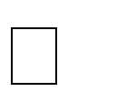**Iftikhar Ahmad,1Muhammad Hamid,1Suhail Yousaf,1Syed Tanveer Shah,2and:** The cultivation of vegetables and fruits is vital for sustaining the global population of 7.5 billion, playing a crucial role in maintaining life on Earth. However, the widespread use of chemicals like fungicides and bactericides to combat plant

diseases is having detrimental effects on the agro-ecosystem. The prevalence of crop diseases on a large scale negatively impacts both the quantity and quality of production. To address this issue, our research focuses on developing a reliable and swift method for the early identification and diagnosis of tomato leaf diseases using convolutional neural network (CNN) techniques.

We explore four CNN architectures—VGG-16, VGG-19, ResNet, and Inception V3— employing feature extraction and parameter tuning to effectively classify and identify tomato leaf diseases. Our evaluation involves testing these models on two datasets: one from a controlled laboratory environment and another consisting of data collected from real-world field conditions. Interestingly, we find that all architectures exhibit superior performance on the laboratory-based dataset compared to the field- based data, with performance metrics showing a variance in the range of 10%–15%. Inception V3 emerges as the top-performing algorithm on both datasets, showcasing its effectiveness in disease identification and classification.

**Summary:** Our research focuses on using convolutional neural network (CNN) techniques to identify and classify tomato leaf diseases, addressing the negative impact of chemical use on crops. We explore four CNN architectures and test them on both laboratory and field datasets. While all architectures perform better on the laboratory-based dataset, Inception V3 stands out as the best-performing algorithm on both datasets. The study highlights the need for reliable methods to detect plant diseases early and the challenges in adapting models to real-world field conditions.

1. [**Manpreet Kaur**](https://ieeexplore.ieee.org/author/37085616114)**;** [**Rekha Bhatia**](https://ieeexplore.ieee.org/author/37088370899)**:** Detecting plant leaf diseases at an early stage is crucial for the Indian economy, as 10-30% of crops are damaged without early detection. Various methods are employed for different crops, and this study focuses on using a pretrained Deep Learning Model to detect and classify Tomato Leaf diseases. The dataset is sourced from the plant village repository, categorized into six diseased and one healthy class. The implementation is carried out in MATLAB, utilizing features extracted from the Fully Connected Layer of the pre-trained ResNet model. Training is conducted separately, employing a linear learner of the Error- Correcting Output Codes (ECOC) for classification, resulting in a highly accurate model. Evaluation metrics such as Accuracy, Precision, F-Score, Specificity, and

False Positive Rate demonstrate the proposed model's superior performance compared to the base article.

**Summary:** This study focuses on the early detection of plant leaf diseases in India, where 10-30% of crops are damaged before being identified. Using a pretrained Deep Learning Model, specifically ResNet, the research utilizes a dataset of Tomato Leaf images with six diseased and one healthy category. Implemented in MATLAB®, the model extracts features from the Fully Connected Layer, employing a linear learner of the ECOC for classification. The trained model exhibits higher accuracy, precision, F-score, specificity, and a lower false positive rate compared to the base article, showcasing its effectiveness in disease classification.

1. [**Robert G. de Luna**](https://ieeexplore.ieee.org/author/37086323407)**;** [**Elmer P. Dadios**](https://ieeexplore.ieee.org/author/37344479100)**;** [**Argel A. Bandala**](https://ieeexplore.ieee.org/author/37073045300)**:** The integration of smart farming infrastructure is a groundbreaking technology that enhances agricultural production, including tomatoes, by considering variables like environment, soil, and sunlight. Despite these considerations, the presence of diseases in tomato plants remains inevitable. Leveraging recent advancements in computer vision enabled by deep learning, this study introduces an innovative solution for efficient disease detection in tomato plants.

A motor-controlled image capturing box was developed to capture four sides of each tomato plant, facilitating the detection and recognition of leaf diseases. The test subject was the Diamante Max tomato breed, and the system was specifically designed to identify Phoma Rot, Leaf Miner, and Target Spot diseases. Using a dataset of 4,923 images of diseased and healthy tomato leaves collected under controlled conditions, a deep convolutional neural network was trained to recognize these diseases.

The system employed Convolutional Neural Network (CNN) to identify the presence of tomato diseases. The F-RCNN trained anomaly detection model achieved an 80% confidence score, while the Transfer Learning disease recognition model demonstrated an accuracy of 95.75%. In real-world implementation, the automated image capturing system achieved a recognition accuracy of 91.67% in identifying tomato plant leaf diseases.

**Summary:** This study introduces a smart farming system using innovative technology to enhance tomato plant farming. By leveraging deep learning and

computer vision, the research developed a motor-controlled image capturing system to efficiently detect and recognize leaf diseases in tomato plants. Specifically focusing on Phoma Rot, Leaf Miner, and Target Spot diseases in the Diamante Max tomato breed, the system utilized a dataset of 4,923 images for training a convolutional neural network (CNN). The automated image capturing system achieved a notable 91.67% accuracy in real-world implementation, showcasing the effectiveness of the proposed solution for tomato plant disease detection and diagnosis.

1. [**Majji V Applalanaidu**](https://ieeexplore.ieee.org/author/37088822003)**;** [**G. Kumaravelan**](https://ieeexplore.ieee.org/author/37887936200)**:** This study aims to identify recent advancements in plant disease detection and classification systems utilizing Machine Learning (ML) and Deep Learning (DL) models. Over 45 papers published between 2017 and 2020 were gathered from peer-reviewed journals in databases like Scopus and Web of Science, focusing on keywords such as plant disease identification, recognition, and classification with ML and DL algorithms. The analysis presents a structured overview of various plant disease classification models in well-organized tables.

The paper conducts a systematic literature review on the applications of state-of-the- art ML and DL algorithms, including Support Vector Machine (SVM), Neural Network (NN), K-Nearest Neighbor (KNN), Naïve Bayes (NB), and popular DL algorithms such as AlexNet, GoogLeNet, and VGGNet. Each algorithm is characterized by processing methods like image segmentation and feature extraction. Standardized experimental setup metrics, such as the total number of datasets used, diseases considered, type of classifier, and classification accuracy percentage, are provided for each algorithm.

The study serves as a valuable resource for researchers seeking to identify plant diseases through data-driven approaches. Additionally, the application of the studied ML/DL approaches in developing mobile-based applications is expected to contribute to increased agricultural productivity.

**Summary:** This study explores recent advancements in plant disease detection and classification systems, utilizing Machine Learning (ML) and Deep Learning (DL) models. Analyzing over 45 papers published between 2017 and 2020, the research focuses on keywords like plant disease identification and classification with ML and

DL algorithms. The systematic literature review covers various models, presenting a detailed analysis in organized tables.

State-of-the-art ML and DL algorithms such as Support Vector Machine, Neural Network, K-Nearest Neighbor, Naïve Bayes, AlexNet, GoogLeNet, and VGGNet are discussed, each characterized by image segmentation, feature extraction, and standardized experimental metrics. These include the total number of datasets, diseases considered, type of classifier, and classification accuracy percentage.

The findings serve as a valuable resource for researchers employing data-driven approaches to identify plant diseases. Furthermore, the application of ML/DL approaches in mobile-based applications is highlighted as a potential contributor to increased agricultural productivity.

# SYSTEM ANALYSIS

* 1. **EXISTING METHOD:**

This model primarily focuses on an existing method that utilizes deep learning algorithms. The approach involves the use of deep learning, a form of transfer learning, to execute the process. However, it is worth noting that this approach did not yield the desired level of high accuracy.

# DISADVANTAGES:

**Limited Dataset and Generalization:** Deep learning models rely on extensive and varied datasets for robust training and the ability to generalize effectively. Nevertheless, compiling a comprehensive dataset encompassing all potential variations and disease types affecting plant leaves is a daunting task. This limitation can impact the model's capacity to accurately identify less prevalent or recently emerged diseases.

**Dependency on Computational Resources:** Deep learning models, particularly intricate ones such as convolutional neural networks (CNNs), necessitate substantial computational resources, including high-performance GPUs and substantial memory. This computational demand renders them costly in terms of resources, constraining their accessibility and usability in environments with limited computing capabilities, notably for small-scale farmers or researchers operating in resource- constrained settings.

**Sensitivity to Environmental Factors and Image Quality:** Models designed for leaf disease detection are susceptible to disruptions caused by fluctuations in lighting conditions, the presence of background clutter, and variations in image quality. Elements like lighting intensity, camera angles, and the specific environmental conditions under which the images are captured can introduce noise into the dataset. This noise can significantly impact the model's performance and reduce its robustness when deployed in real-world applications.

**Interpretability and Explain ability:** Deep learning models, especially those with intricate, multi-layered architectures, are frequently regarded as "black boxes" because of their inherent lack of interpretability and explainability. Deciphering the decision-making mechanisms of these models can prove to be a daunting task. This issue is particularly significant in critical domains like agriculture, where farmers and researchers rely on comprehending the model's rationale for accurate disease diagnosis and informed decision-making.

# PROPOSED SYSTEM:

The proposed method involves the classification of Plant Leaf Disease using custom Centernet framework with densenet-121 of Convolutional Neural Network (CNN) from deep learning . This approach relies on image analysis techniques for the detection of leaf diseases. As a result, achieving accurate classification is a crucial

aspect of the methodology, and it is this classification that the proposed method aims to accomplish. The block diagram illustrating the proposed method is depicted below for reference.

# ADVANTAGES:

**High Accuracy and Reliability:**

Deep learning models, particularly convolutional neural networks (CNNs), have demonstrated remarkable capabilities in image recognition tasks. These models excel at learning intricate patterns and features from leaf images, ultimately resulting in high levels of accuracy and reliability in disease detection. Their proficiency in discerning subtle variations in leaf textures and colors contributes to precise and dependable disease diagnosis, offering a valuable tool for both farmers and researchers in the field of agriculture.

# Automated and Efficient:

The proposed deep learning system serves as an automated solution for leaf disease detection, eliminating the necessity for manual inspection and analysis. This automation introduces a substantial enhancement in efficiency, enabling the swift screening of a considerable number of plants. Such rapid screening is pivotal for timely disease detection and intervention, facilitating early treatment and mitigating the potential spread of diseases throughout crop populations.

# Scalability and Adaptability:

Deep learning models possess the ability to undergo training on diverse datasets and exhibit adaptability in the context of various leaf diseases affecting different plant species. This inherent scalability and versatility endow the proposed system with the capability to effectively address a broad spectrum of agricultural scenarios. Furthermore, as new data becomes accessible, the model can be retrained, thereby continually enhancing its performance and ensuring its readiness to accommodate emerging diseases in the agricultural domain.

# Cost-Effectiveness and Resource Optimization:

Integrating a deep learning-based leaf disease detection system holds the potential for long-term cost-effectiveness. Following the initial phases of model training and

deployment, the system can be employed without the recurring expenses linked to human labor for manual inspections. Furthermore, ongoing advancements in hardware and optimization techniques have led to a reduction in the computational demands for running deep learning models. This progress translates into a more resource-efficient and cost-effective system, offering sustainable benefits over time.

# WORK FLOW OF PROPOSED SYSTEM:

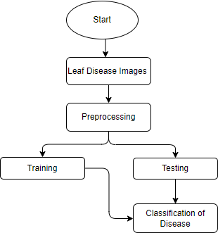

**Fig 1. Block diagram of proposed method**

# REQUIREMENT ANALYSIS

* 1. **Functional and non-functional requirements**

Requirement’s analysis is very critical process that enables the success of a system or software project to be assessed. Requirements are generally split into two types: Functional and non-functional requirements.

**Functional Requirements**: These are the requirements that the end user specifically demands as basic facilities that the system should offer. All these functionalities need to be necessarily incorporated into the system as a part of the contract. These are represented or stated in the form of input to be given to the system, the operation performed and the output expected. They are basically the requirements stated by the user which one can see directly in the final product, unlike the non-functional requirements.

Examples of functional requirements:

* + 1. Authentication of user whenever he/she logs into the system
    2. System shutdown in case of a cyber-attack
    3. A verification email is sent to user whenever he/she register for the first time on some software system.

**Non-functional requirements**: These are basically the quality constraints that the system must satisfy according to the project contract. The priority or extent to which these factors are implemented varies from one project to other. They are also called non-behavioral requirements. They basically deal with issues like:

* + - * Portability
      * Security
      * Maintainability
      * Reliability
      * Scalability
      * Performance
      * Reusability
      * Flexibility

Examples of non-functional requirements:

1. Emails should be sent with a latency of no greater than 12 hours from such an activity.
2. The processing of each request should be done within 10 seconds
3. The site should load in 3 seconds whenever of simultaneous users are > 10000

# Hardware Requirements

Processor - I3/Intel Processor

Hard Disk - 160GB

Key Board - Standard Windows Keyboard Mouse - Two or Three Button Mouse Monitor - SVGA

RAM - 8GB

# Software Requirements:

Operating System : Windows 7/8/10

Server side Script : HTML, CSS, Bootstrap & JS

Programming Language : Python

Libraries : Flask, Pandas, Mysql.connector, Os, Smtplib, Numpy

IDE/Workbench : PyCharm

Technology : Python 3.6+ Server Deployment : Xampp Server Database : MySQL

# ARCHITECTURE

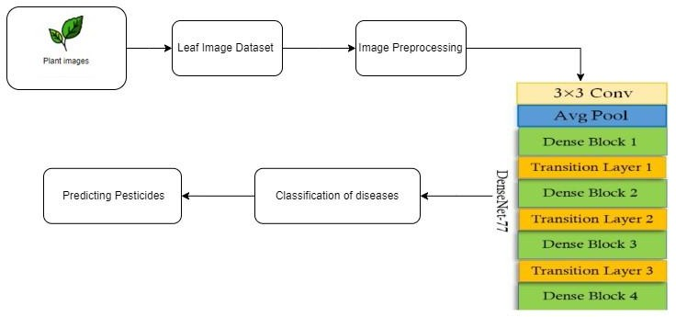

1. **METHODOLOGY**

# 5.1. CONVOLUTIONAL NEURAL NETWORK Step1: convolutional operation

The initial foundational component in our strategic approach is the convolution operation. During this phase, we delve into the concept of feature detectors, which essentially function as the neural network's filters. We explore the realm of feature maps, understanding the process of parameter learning associated with these maps, the mechanics of pattern detection, the successive layers of detection, and the mapping of the resultant findings.

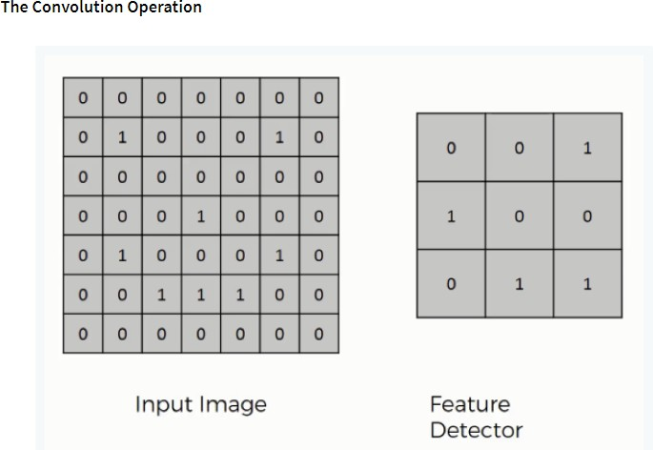

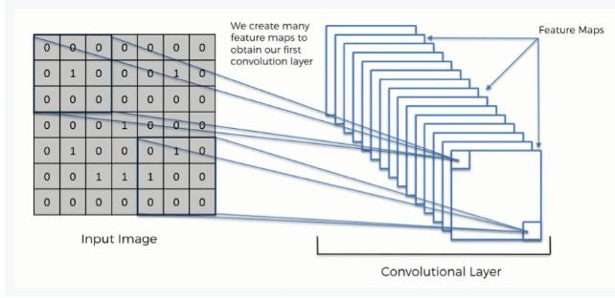

# Step (1b): ReLU Layer

The second facet of this stage encompasses the Rectified Linear Unit, abbreviated as ReLU. We delve into the functionality of ReLU layers and delve into how linearity operates within the framework of Convolutional Neural Networks. While not a prerequisite for comprehending CNNs, a brief lesson in this area can enhance your skill set and knowledge.

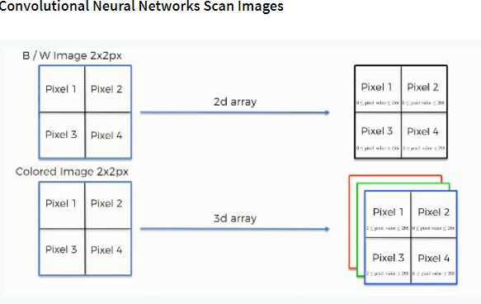

# Step 2: Conv2D

Keras Conv2D layer is a 2D Convolution Layer, responsible for generating a convolution kernel that is applied to the input of the layer. This process leads to the creation of a tensor comprising the resulting outputs.

The term "kernel," within the realm of image processing, refers to a convolution matrix or mask. Kernels serve a crucial role in various image processing operations, including but not limited to blurring, sharpening, embossing, and edge detection. These operations are carried out by performing a convolution between a kernel and an image, allowing for the manipulation and enhancement of visual features within the image data.

# Step 3: Flattening

This will be a brief breakdown of the flattening process and how we move from pooled to flattened layers when working with Convolutional Neural Networks.

# Step 4: Full Connection

In this part, everything that we covered throughout the section will be merged together. By learning this, you'll get to envision a fuller picture of how Convolutional

Neural Networks operate and how the "neurons" that are finally produced learn the classification of images.

# Summary

As we conclude this section, it's a good practice to provide a brief recap of the concepts we've covered. Additionally, if you're inclined to enhance your understanding further, there's an optional tutorial available that delves into Softmax and Cross-Entropy. While not mandatory for this course, familiarity with these concepts can prove valuable, particularly when working with Convolutional Neural Networks. Being well-versed in Softmax and Cross-Entropy can empower you with a deeper comprehension of key aspects in the field of CNNs, making your journey in this domain more insightful and productive.

# Convolutional neural network (CNN):

A convolutional neural network consists of an input layer, hidden layers and an output layer. In any feed-forward neural network, any middle layers are called hidden because their inputs and outputs are masked by the activation function and final convolution.

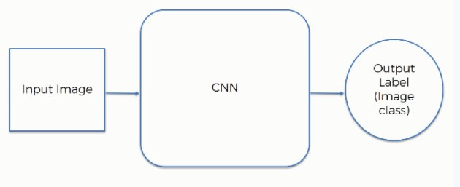

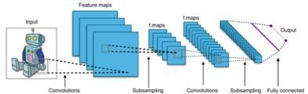

# Fig 2. CNN Architecture

* 1. **ARTIFICIAL NEURAL NETWORK (ANN):**

Artificial Neural Network (ANN) architecture draws inspiration from the structure and functionality of biological neural networks. Much like neurons in the human brain, ANNs comprise interconnected neurons organized into different layers. A popular type of ANN is the feedforward neural network, which features an input layer responsible for receiving external data for pattern recognition, an output layer that provides the solution to a given problem, and at least one hidden layer serving as an intermediate layer that acts as an intermediary between the input and output layers. Neurons in adjacent layers are connected through acyclic arcs, allowing for the flow of information in one direction. ANNs employ training algorithms to learn from datasets, adjusting neuron weights based on the error rate between the desired target output and the actual output. The backpropagation algorithm is commonly used for this purpose, enabling ANNs to learn and adapt to the provided data. The general structure of ANN is shown in Fig.

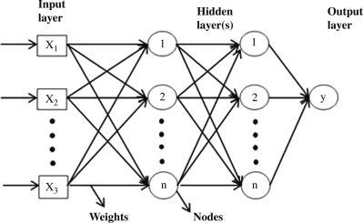

# RESNET50:

ResNet50 is a convolutional neural network which has a depth of 50 layers. It was build and trained by Kaiming He, Xiangyu Zhang, Shaoqing Ren, and Jian Sun in their 2015 and you can access the model performance results on their paper, titled Deep Residual Learning for Image Recognition. This model is also trained on more than 1 million images from the ImageNet database. Just like VGG-19, it can classify up to 1000 objects and the network was trained on 224x224 pixels colored images. Here is brief info about its size and performance:

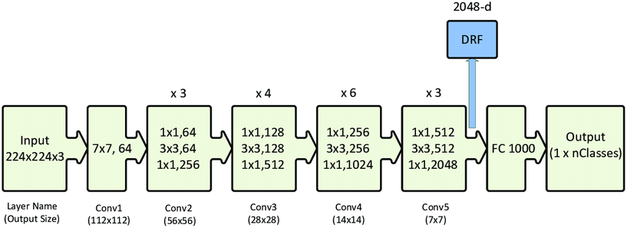

# Fig 5. ResNet50 Architecture

In summary, the introduction of the residual network, or ResNet, marked a significant breakthrough in the realm of training deep convolutional neural networks, particularly for computer vision-related tasks. The original ResNet, with its 34 layers and 2-layer blocks, laid the foundation for this innovation. Subsequent advanced variants, such as ResNet50, adopted 3-layer bottleneck blocks, aiming to achieve enhanced accuracy and reduced training time. Keras, a widely popular deep learning API, is

renowned for its user-friendly approach to model construction. It offers a range of pre-trained models, including ResNet50, which is readily available for experimentation. Consequently, building a residual network in Keras for tasks like image classification is a relatively straightforward process, requiring just a few simple steps.

# DenseNet201:

DenseNet represents a notable advancement in neural networks, particularly in the realm of visual object recognition. While it shares some similarities with ResNet, there are fundamental distinctions. ResNet employs an additive approach (+), merging the output of the previous layer (identity) with the succeeding layer, whereas DenseNet adopts a concatenation approach (.) by combining the previous layer's output with the forthcoming layer. This approach was specifically devised to address the issue of declining accuracy attributed to the vanishing gradient problem in deep neural networks. In simpler terms, as information traverses a longer path from the input layer to the output layer, it tends to vanish before reaching its destination.

The core of DenseNet lies in the concept of connecting the output of one layer to the input of the next layer through a composite function operation. This composite operation encompasses a convolution layer, pooling layer, batch normalization, and a non-linear activation layer. The remarkable feature of DenseNet is its densely connected architecture, which ensures that the network boasts L (L+1)/2 direct connections, where L represents the total number of layers within the architecture. Various versions of DenseNet, such as DenseNet-121, DenseNet-160, and DenseNet-201, are tailored based on the number of layers they incorporate. For instance, DenseNet-121 comprises 121 layers.

Notably, whether through addition or concatenation, these layer connections are feasible when feature map dimensions are consistent. In cases where the feature map dimensions differ, DenseNet divides the architecture into DenseBlocks. Within a DenseBlock, the number of filters may vary, but the dimensions are maintained

uniform. Transition Layers play a pivotal role in transitioning between different layers, applying batch normalization and downsampling. This structure is a crucial component of convolutional neural networks, enhancing their performance.

# SYSTEM DESIGN

* 1. **Introduction of Input Design:**

In an information system, input is the raw data that is processed to produce output. During the input design, the developers must consider the input devices such as PC, MICR, OMR, etc.

Therefore, the quality of system input determines the quality of system output. Well- designed input forms and screens have following properties −

* It should serve specific purpose effectively such as storing, recording, and retrieving the information.
* It ensures proper completion with accuracy.
* It should be easy to fill and straightforward.
* It should focus on user’s attention, consistency, and simplicity.
* All these objectives are obtained using the knowledge of basic design principles regarding −
  + What are the inputs needed for the system?
  + How end users respond to different elements of forms and screens.

# Objectives for Input Design:

The objectives of input design are −

* To design data entry and input procedures
* To reduce input volume
* To design source documents for data capture or devise other data capture methods
* To design input data records, data entry screens, user interface screens, etc.
* To use validation checks and develop effective input controls.

# Output Design:

The design of output is the most important task of any system. During output design, developers identify the type of outputs needed, and consider the necessary output controls and prototype report layouts.

# Objectives of Output Design:

The objectives of input design are:

* To develop output design that serves the intended purpose and eliminates the production of unwanted output.
* To develop the output design that meets the end user’s requirements.
* To deliver the appropriate quantity of output.
* To form the output in appropriate format and direct it to the right person.
* To make the output available on time for making good decisions.

# UML Diagrams:

**USE CASE DIAGRAM**

▶ A use case diagram in the Unified Modeling Language (UML) is a type of behavioral diagram defined by and created from a Use-case analysis.

▶ Its purpose is to present a graphical overview of the functionality provided by a system in terms of actors, their goals (represented as use cases), and any

dependencies between those use cases.

▶ The main purpose of a use case diagram is to show what system functions

are performed for which actor. Roles of the actors in the system can be depicted.

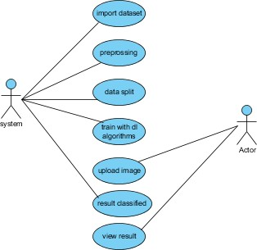

# CLASS DIAGRAM

In software engineering, a class diagram in the Unified Modeling Language (UML) is a type of static structure diagram that describes the structure of a system by showing the system's classes, their attributes, operations (or methods), and the relationships among the classes. It explains which class contains information

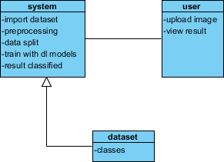

# SEQUENCE DIAGRAM

▶ A sequence diagram in Unified Modeling Language (UML) is a kind of interaction diagram that shows how processes operate with one another and

in what order.

▶ It is a construct of a Message Sequence Chart. Sequence diagrams are sometimes called event diagrams, event scenarios, and timing diagrams

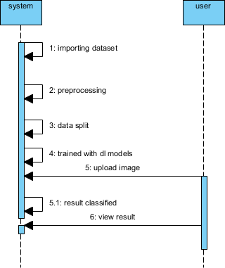

# COLLABORATION DIAGRAM:

In collaboration diagram the method call sequence is indicated by some numbering technique as shown below. The number indicates how the methods are called one after another. We have taken the same order management system to describe the collaboration diagram. The method calls are similar to that of a sequence diagram. But the difference is that the sequence diagram does not describe the object organization whereas the collaboration diagram shows the object organization.

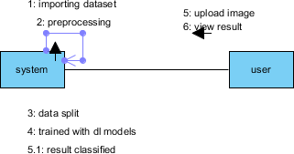

# DEPLOYMENT DIAGRAM

Deployment diagram represents the deployment view of a system. It is related to the component diagram. Because the components are deployed using the deployment diagrams. A deployment diagram consists of nodes. Nodes are nothing but physical hardware’s used to deploy the application.



# ACTIVITY DIAGRAM:

Activity diagrams are graphical representations of workflows of stepwise activities and actions with support for choice, iteration and concurrency. In the Unified Modeling Language, activity diagrams can be used to describe the business and operational step-by-step workflows of components in a system. An activity diagram shows the overall flow of control.

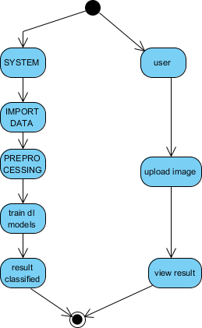

# COMPONENT DIAGRAM:

A component diagram, also known as a UML component diagram, describes the organization and wiring of the physical **c**omponents in a system. Component diagrams are often drawn to help model implementation details and double-check that every aspect of the system's required function is covered by planned development.



# ER DIAGRAM:

An Entity–relationship model (ER model) describes the structure of a database with the help of a diagram, which is known as Entity Relationship Diagram (ER Diagram).

An ER model is a design or blueprint of a database that can later be implemented as a database. The main components of E-R model are: entity set and relationship set.

An ER diagram shows the relationship among entity sets. An entity set is a group of similar entities and these entities can have attributes. In terms of DBMS, an entity is a table or attribute of a table in database, so by showing relationship among tables and their attributes, ER diagram shows the complete logical structure of a database. Let’s have a look at a simple ER diagram to understand this concept.

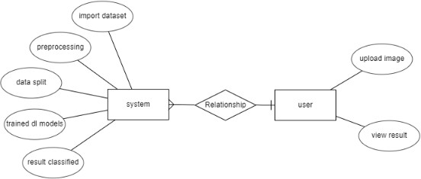

# DFD DIAGRAM:

A Data Flow Diagram (DFD) is a traditional way to visualize the information flows within a system. A neat and clear DFD can depict a good amount of the system requirements graphically. It can be manual, automated, or a combination of both. It shows how information enters and leaves the system, what changes the information and where information is stored. The purpose of a DFD is to show the scope and boundaries of a system as a whole. It may be used as a communications tool between a systems analyst and any person who plays a part in the system that acts as the starting point for redesigning a system.

# Zero level Diagram:



**Level 1 Diagram:**

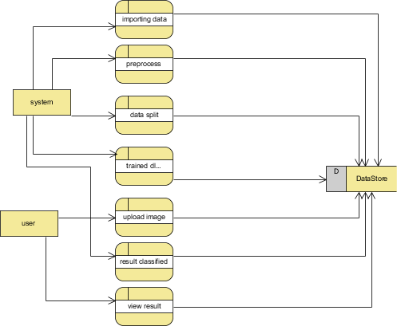

# Level 2 Diagram:

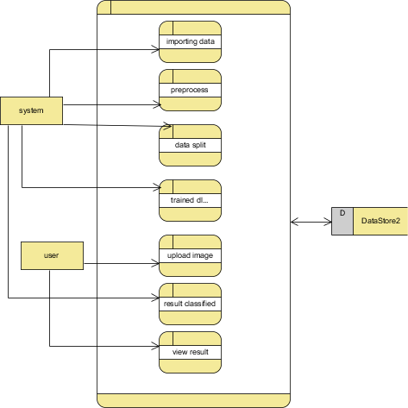

**OUTPUT SCREEN SHOTS WITH DESCRIPTION.**

**Home:** In our project, we are classifying the presence of Plant Leaf Diseases Classification, with the help of deep learning and machine learning.

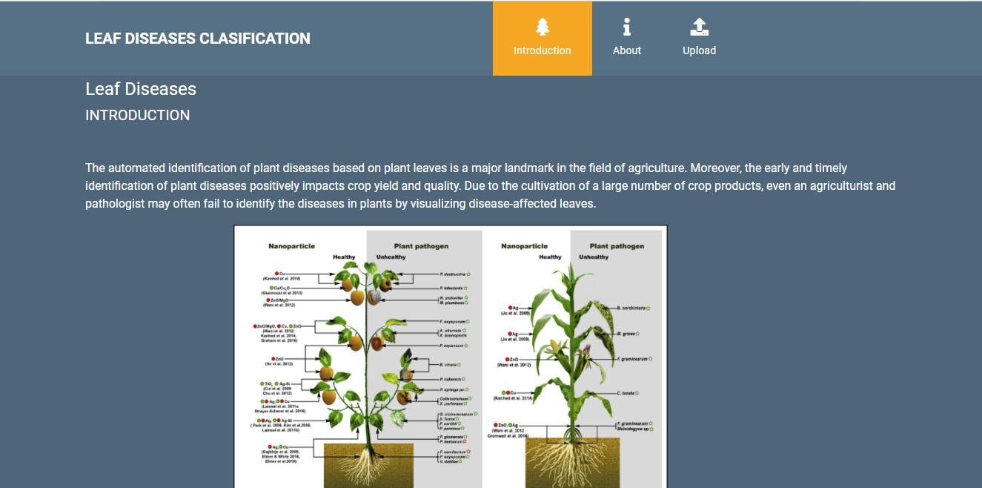

**Fig1:** Home

**About Project:** Here the user will get a breif idea about the project.

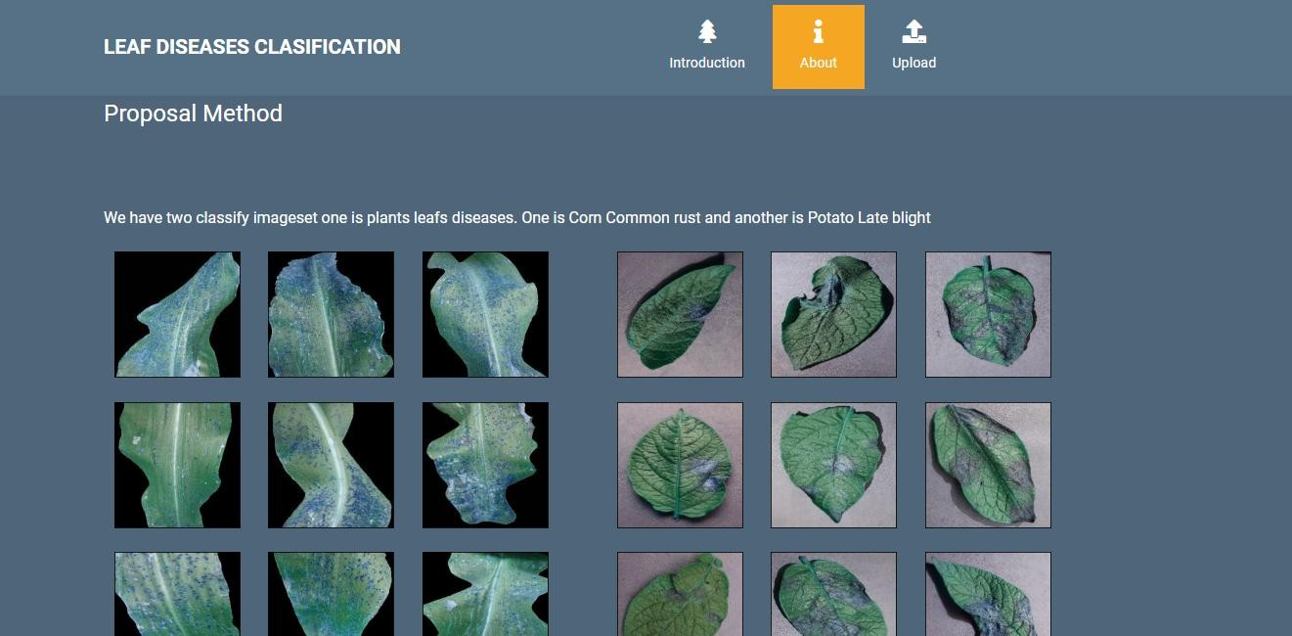

**Fig2**: About Project

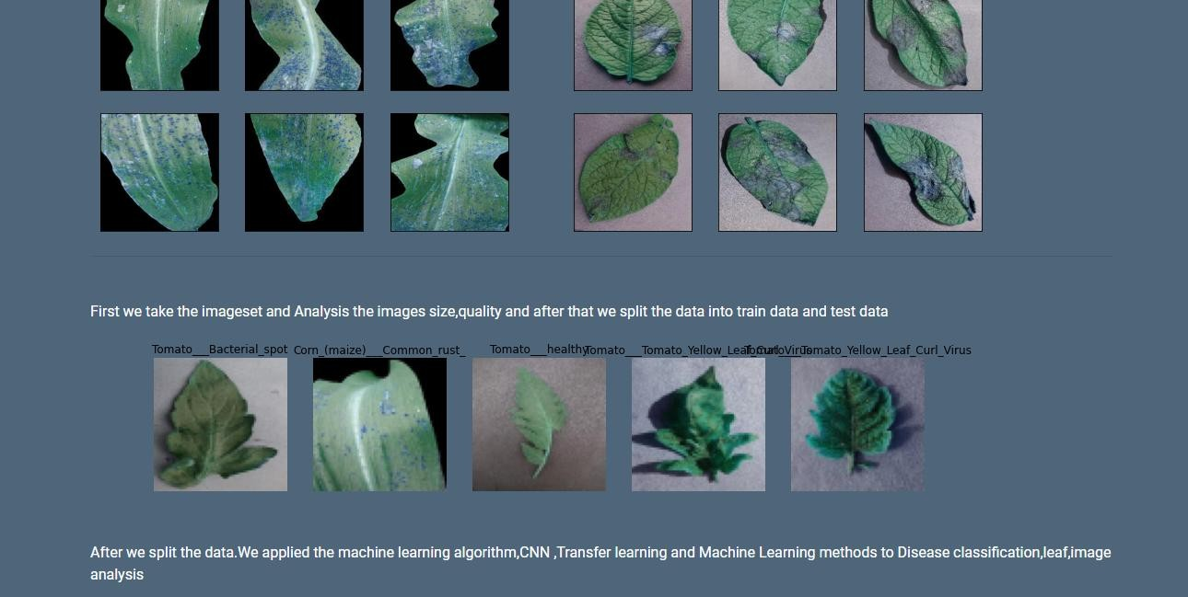

**Fig2**: About Project

# Upload Image:

Here the images can be uploaded those which are to be classified.

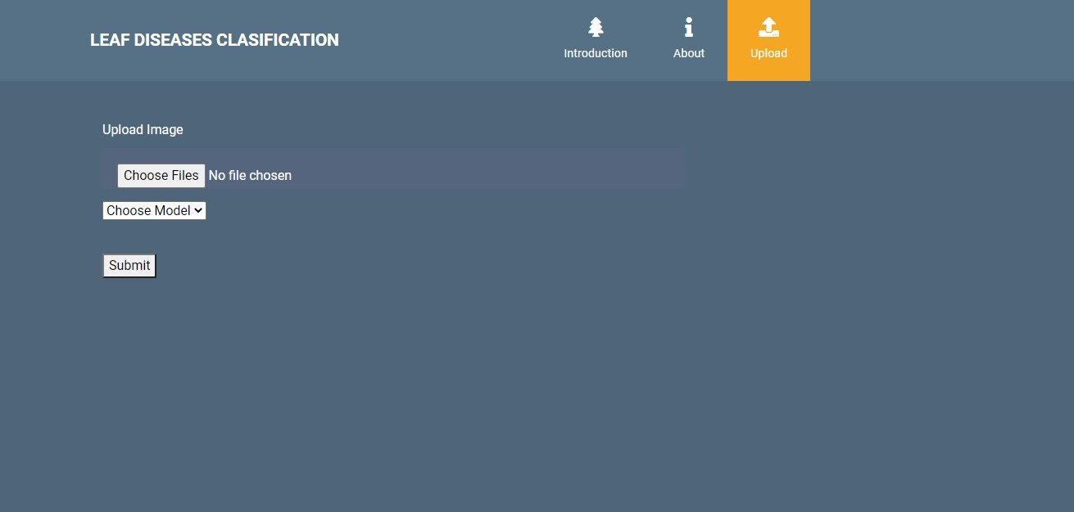

**Fig3**: Image Uploading

# Model choosing:

Here the model can be selected, by which the image is to be classified.

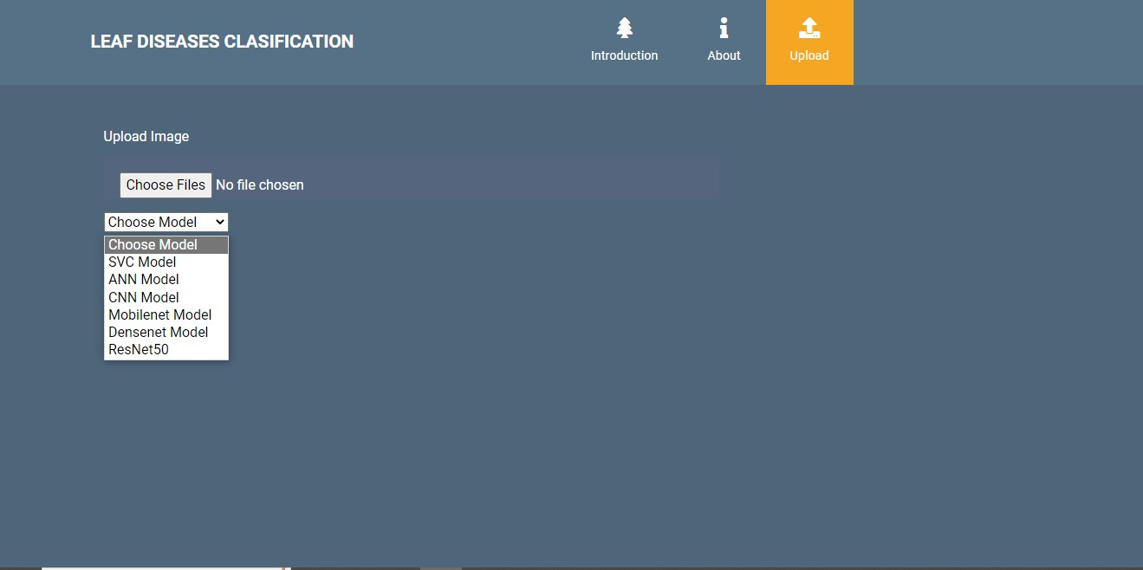

**Fig4:** Model choosing

# Classified output:

The uploaded image is classified as the Corn_(maize) Cercospora_leaf_spot Gray_leaf_spot.

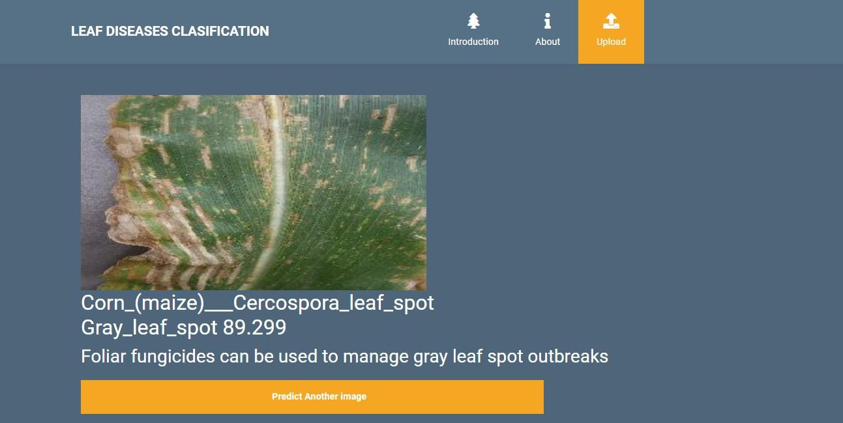

**Fig5**: Classified output

# Classified output:

The uploaded image is classified as the Corn_(maize) Common_rust_.

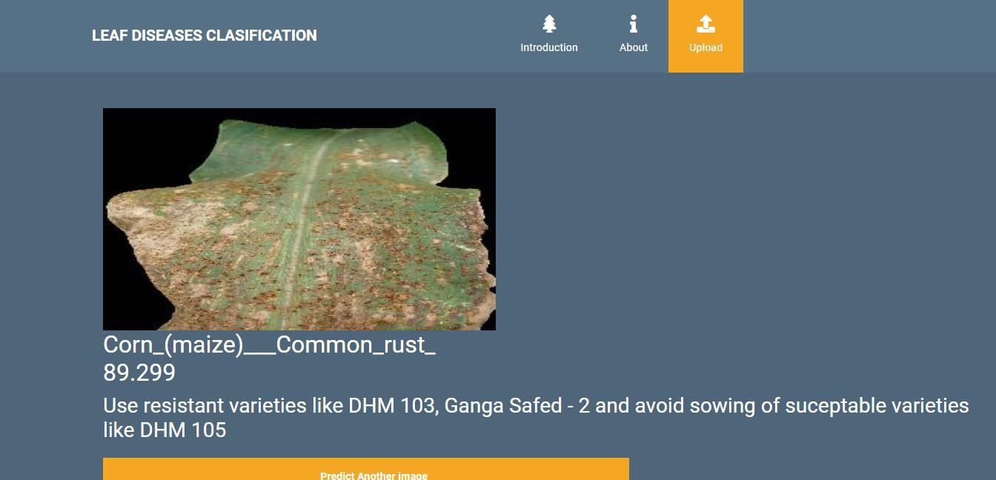

**Fig5**: Classified output

# Classified output:

The uploaded image is classified as the Corn_(maize) healthy.

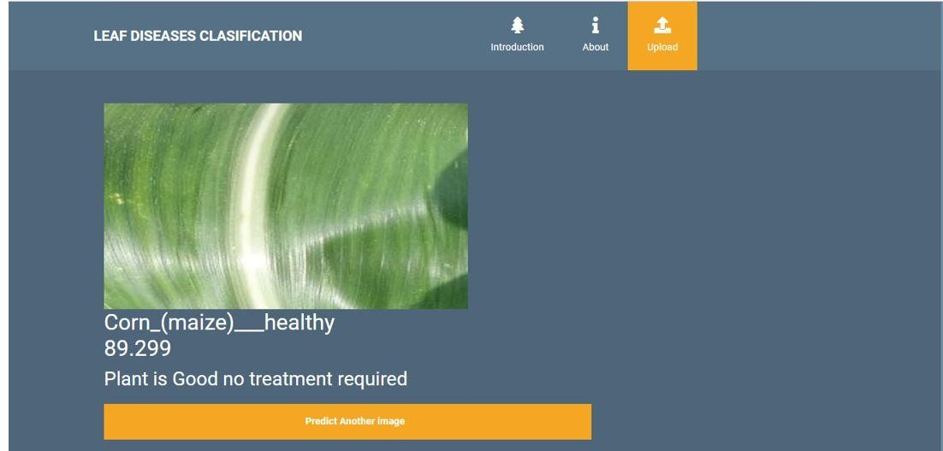

**Fig5**: Classified output

# Classified output:

The uploaded image is classified as the Corn_(maize) Northern_Leaf_Blight.

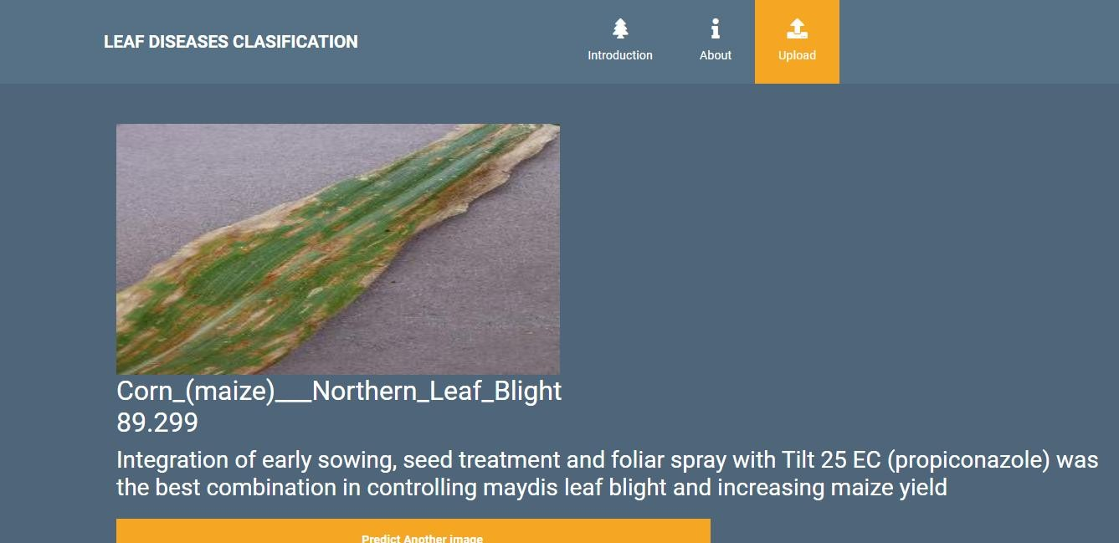

**Fig5**: Classified output

# Classified output:

The uploaded image is classified as the Potato Early_blight.

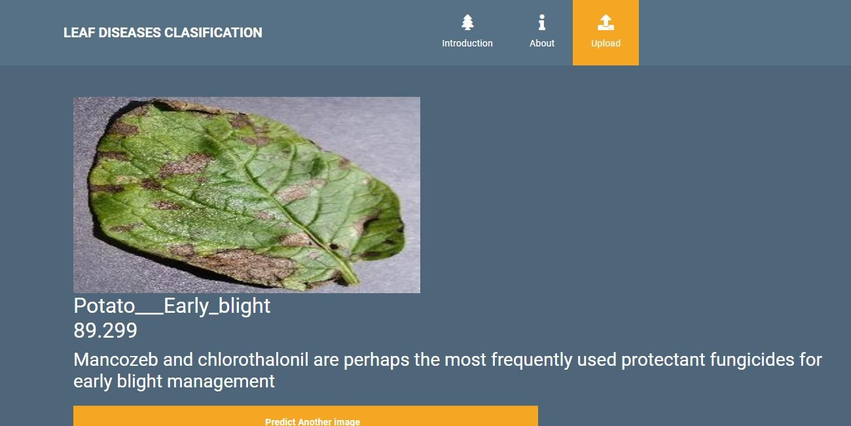

**Fig5**: Classified output

# Classified output:

The uploaded image is classified as the Potato healthy.

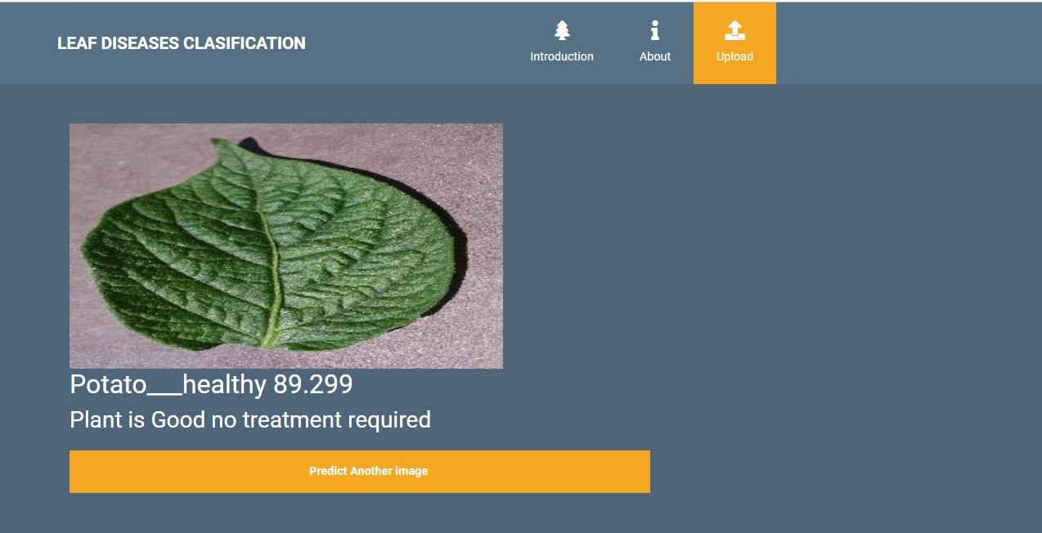

**Fig5**: Classified output

# Classified output:

The uploaded image is classified as the Potato Late_blight.

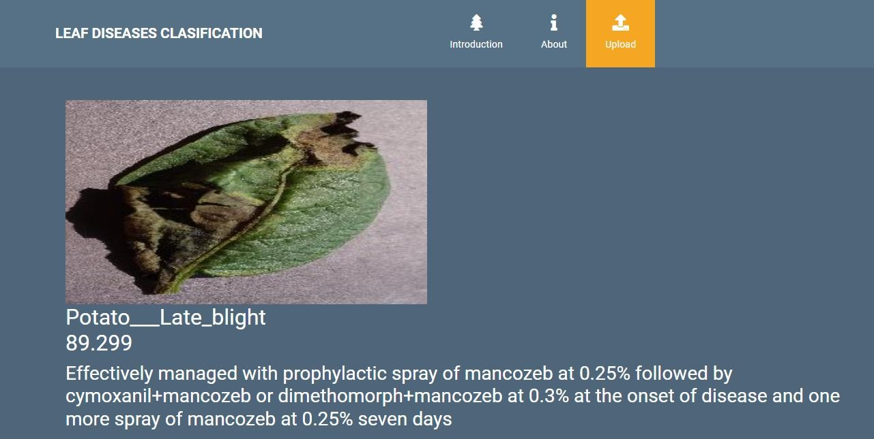

**Fig5**: Classified output

# Classified output:

The uploaded image is classified as the Tomato Bacterial_spot.

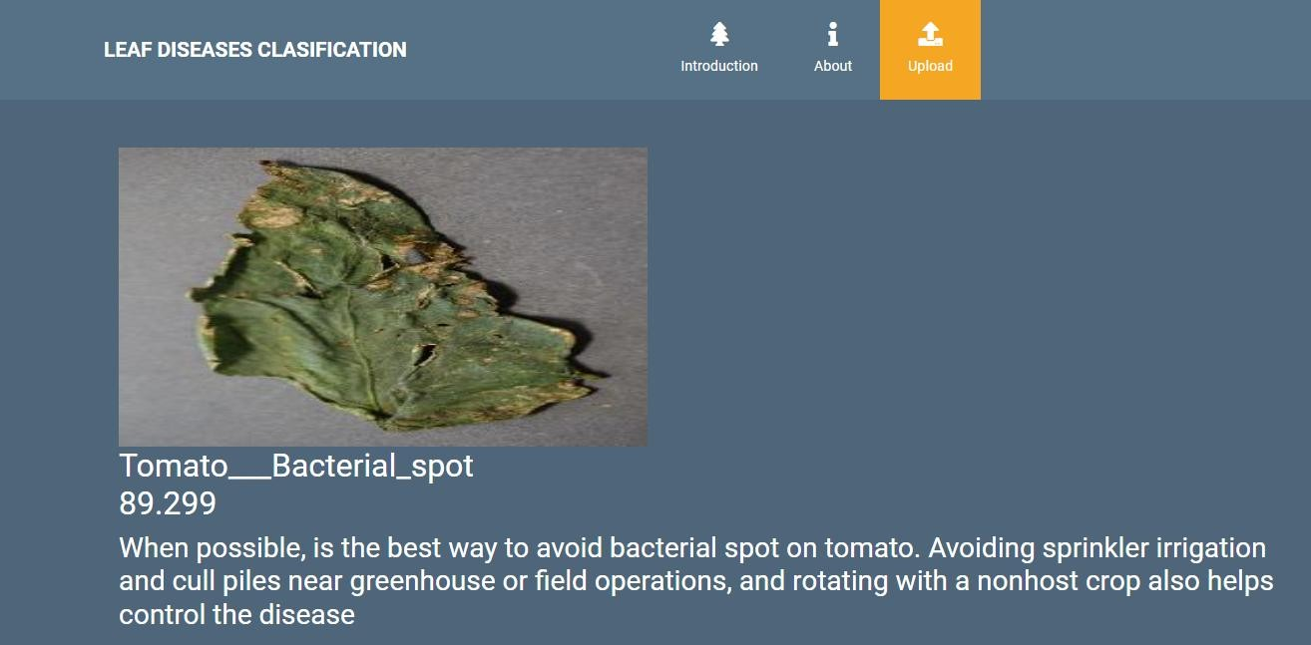

**Fig5**: Classified output

# Classified output:

The uploaded image is classified as the Tomato healthy.

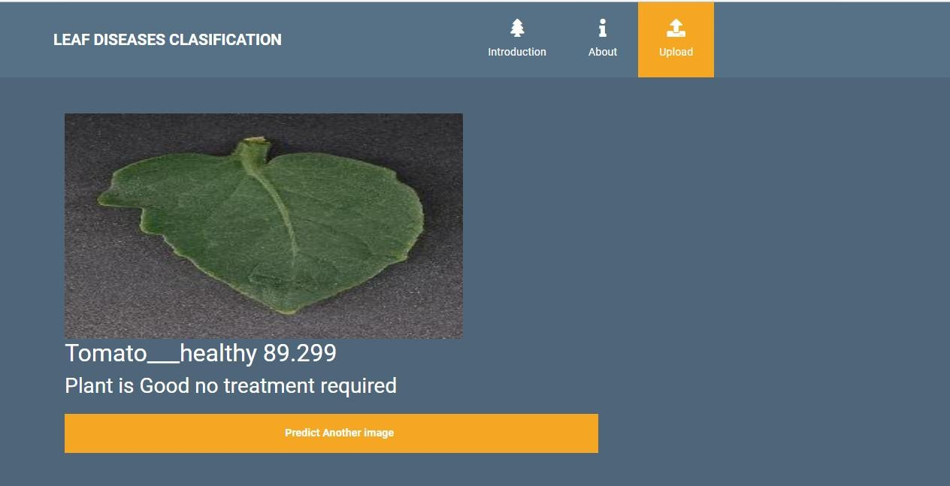

**Fig5**: Classified output

# Classified output:

The uploaded image is classified as the Tomato Late_blight.

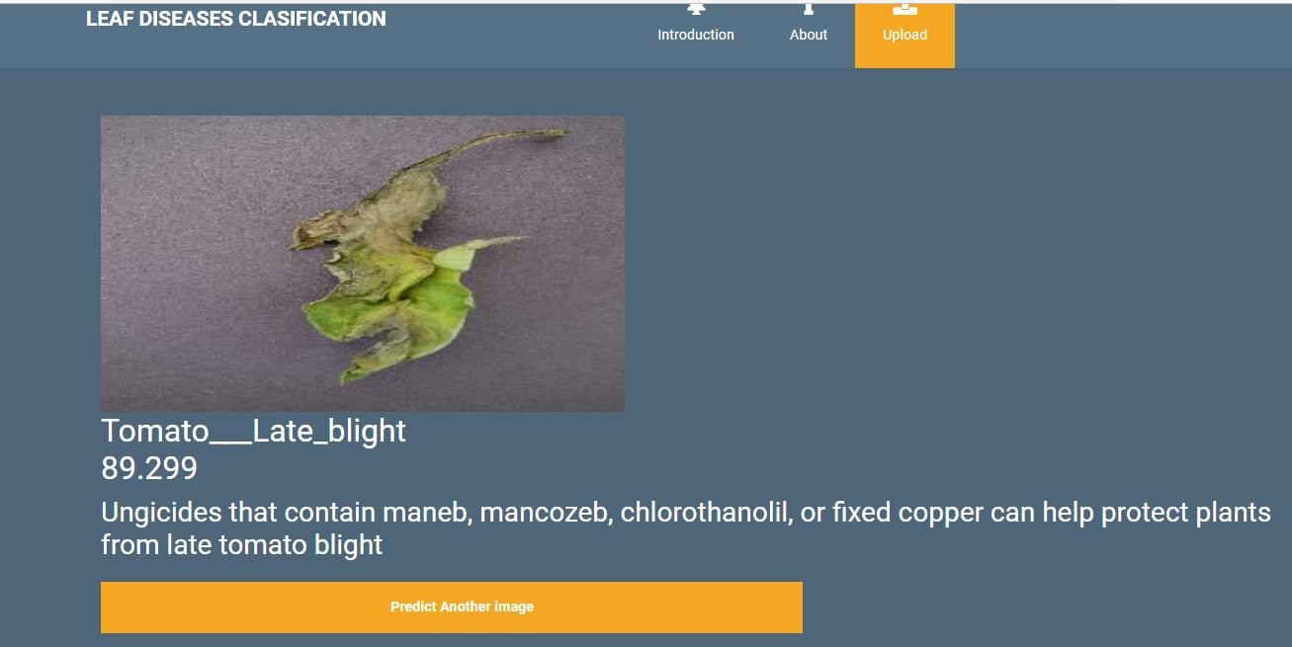

**Fig5**: Classified output

# Classified output:

The uploaded image is classified as the Tomato Tomato_Yellow_Leaf_Curl_Virus.

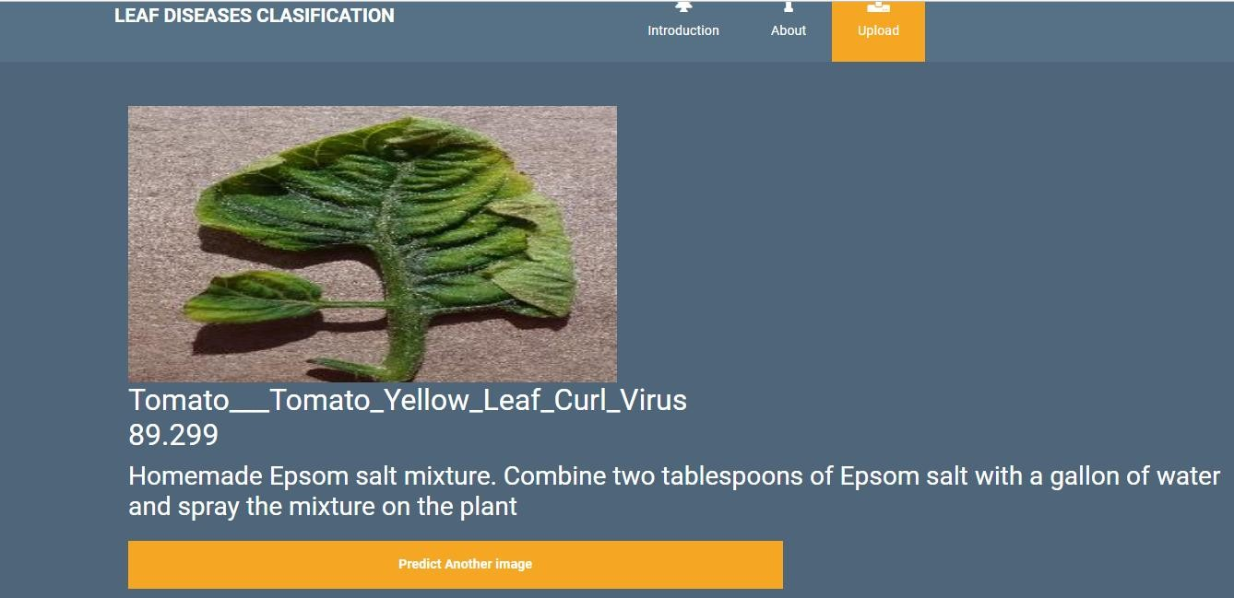

**Fig5**: Classified output

# TEST CASES:

|  |  |  |
| --- | --- | --- |
| **Input** | **Output** | **Result** |

|  |  |  |
| --- | --- | --- |
| Input text | Tested for the classification of Plant Disease Classification | Success |

**TEST CASES MODEL BUILDING:**

|  |  |  |  |  |  |
| --- | --- | --- | --- | --- | --- |
| **S.NO** | **Test cases** | **I/O** | **Expected O/T** | **Actual O/T** | **P/F** |
| 1 | Read the dataset. | Dataset path. | Dataset need to read  successfully. | Dataset fetched successfully. | P |
| 2 | Performing pre- processing on the  dataset | Pre- processing part takes place | Pre- processing should be performed on dataset | Pre- processing successfully completed. | P |
| 3 | Model Building | Model Building for the clean data | Need to create model using required algorithms | Model Created Successfully. | P |
| 4 | Classification | Input image provided. | Output should be the  Identification of Plant  Disease Classification | Model classified successfully | P |

# CONCLUSION:

In this project, our primary achievement lies in the successful classification of images related to the identification of plant leaf diseases. We have effectively categorized these images into either healthy or affected by plant leaf diseases, employing a combination of deep learning and machine learning techniques. Our dataset encompasses a diverse range of images associated with Plant Leaf Diseases Classification, featuring various types of diseases and plants in different health conditions. To accomplish this classification task, we harnessed the power of Support Vector Classifier (SVC), Convolutional Neural Networks (CNN), Artificial Neural Networks (ANN), and further leveraged transfer learning methods like ResNet50, MobileNet, and DenseNet. Following the training process, we conducted rigorous testing by uploading new images, allowing us to accurately classify and identify their health status. This project represents a significant step forward in

automated plant disease detection and classification, contributing to the field of agriculture and plant health management.

# FUTURE SCOPE:

The outcomes of this project hold substantial promise for future applications, particularly in the efficient classification of various types of plant diseases. This advancement paves the way for the early prediction of diseases in plants, enabling proactive treatment in the initial stages. By swiftly identifying and classifying plant diseases, we can take timely measures to initiate the necessary treatment, safeguarding the health of individual plants, and preventing the spread of diseases to neighboring plants. This proactive approach not only ensures the well-being of the affected plants but also contributes to the overall health and productivity of agricultural crops. Ultimately, our work signifies a significant step towards enhancing plant disease management and promoting sustainable agricultural practices.

# REFERENCES

* + 1. V. S. Babu, R. Satheesh Kumar and R. Sunder, "A comparative Study on Disease Detection of Plants Using Machine Learning Techniques", 2021 7 th International Conference on Advanced Computing and Communicating Systems (ICACCS 2021) .
    2. Yang Zhang, Chenglong Song and Dongwen Zhang, Deep Learning-Based Object Detection Improvement for Tomato Disease, IEEE, 2020.
    3. Jun Sun, Yu Yang, Xiaofei He and Xiaohong Wu, Northern Maize Leaf Blight Detection under Complex Field Environment Based on Deep Learning, IEEE, 2020.
    4. Peng Jiang, Yeuhan Chen, Bin Liu, Dongiian He and Chunquan Liang, Real- Time Detection of Apple Leaf Diseases Using Deep Learning Approach Based on Improved Convolutional Neural Networks, IEEE, 2019.
    5. Nikita Jadhav, Himali Kasar, Sumita Chandak and Shivani Machha, "Crop Leaf Disease Diagnosis using Convolutional Neural Network", Published 2020 Biology International Journal of Trend in Scientific Research and Development.
    6. G. Geetha, S. Samundeswari, Saranya Gangadhara Moorthy, K. Meenakshi and M. Nithya, "Plant Leaf Disease Classification and Detection System Using Machine Learning", December 2020 Journal of Physics Conference Series (ICCPET 2020).
    7. M. Francis and C. Deisy, "Disease Detection and Classification in Agricultural Plants Using Convolutional Neural Networks", A Visual Understanding Computer Science 2019 6 th International Conference on Signal Processing and Integrated Networks (SPIN) , 2019.
    8. S. Hari, M. Siva Kumar, P. Renuga, S. Karthikeyan and S. Suriya, "Detection of Plant Disease by Leaf Image Using Convolutional Neural Network", Computer Science 2019 International Conference on Vision Towards Emerging Trends in Communication and Networking (ViTECoN) 2019.
    9. Md Rahmat Ullah, Nagifa Anjum and Abdus Sattar, "Plant Disease Recognition Using Machine Learning", 2019 8 th International Conference System Modeling and Advancement in Research Trenda (SMART 2019) .
    10. Melike Sardogan, Adem Tuncer and Yunnus Ozen, "Plant Leaf Disease Detection and Classification Based on CNN with LVQ Algorithm", 3 rd International Conference on Computer Science and Engineering (UBMK) Posted , 2018.
    11. Shima Ramesh Maniyath, P V Vinod, M Niveditha, P. R, P. N, N Shashank, et al., "Plant Disease Detection Using Machine Learning", 2018 International Conference on Design Innovations for 3C's Compute Communicate Control (ICDI3C).
    12. P. Maheswari, P. Raja and N. M. Ghangoankar, "Intelligent Disease Detection System for Early Blight of Tomato Using Foldscope: A Pilot Study", 2018 IEEE 4th International Symposium in Robotics and Manufacturing Automation (ROMA).
    13. Yow-Wen Tian, Peng-Hui Zheng and Rui-Yao Shi, "The Detection System for Greenhouse Tomato Disease Degree Based on Android Platform", 3 rd

International Conference on Information Science and Control Engineering Posted , 2016.

* + 1. C Ravi, Jibu Shinde, C Mathew and C Y Patil, "Segmentation Technique for Soybean Leaves Disease Detection", International Journal of Advanced Research, vol. 3, no. 5, 2015.
    2. M Ramakrishna, A Sahaya and Anselin Nisha, "Groundnut Leaf Disease Detection and Classification by using Nack Propagation Algorithm", IEEE International Conference, 2015.
    3. U. Mokhtar, Mona A. S. Ali, Aboul Ella Hassenian and H. Hefny, "Tomato Leaves Diseases Detection Approach Based on Support Vector Machines", 2015 11 th International Computer Engineering Conference (ICENCO 2015)
    4. A. Camargo and J.S. Smith, “An image-processing based algorithm to automatically identify plant disease visual symptoms,” Biosystems Engineering, vol.102, pp.9–21, January 2009.
    5. J.S. Cope, D. Corney, J.Y. Clark, P. Remagnino, and P. Wilkin, “Plant species identification using digital morphometrics: A review,” Expert Systems with Applications, vol.39, pp.7562–7573, June 2012.
    6. J. Garcia and A. Barbedo, “Using digital image processing for counting whiteflies on soybean leaves,” Journal of Asia-Pacific Entomology, vol.17, pp.685–694, December 2014.
    7. A. Gongal, S. Amatya, M. Karkee, Q. Zhang, and K. Lewis, “Sensors and systems for fruit detection and localization: A review,” Computers and Electronics in Agriculture, vol.116, pp.8–19, August 2015.